**ASSIGNMENT II**

# AGGREGATE FUNCTION COMMANDS :

## COUNT ROWS COMMANDS:

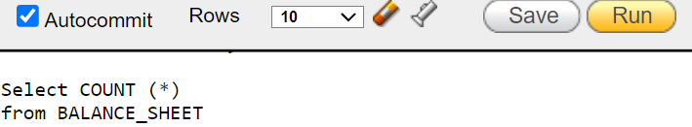

# OUTPUT:

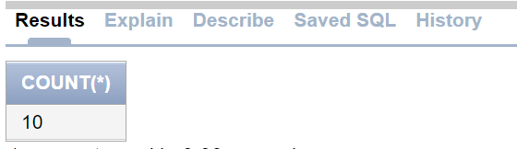

## COUNT DISTINT QTY COMMAND:

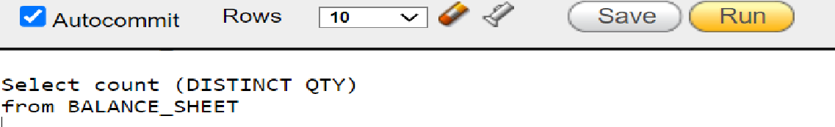

# OUTPUT:

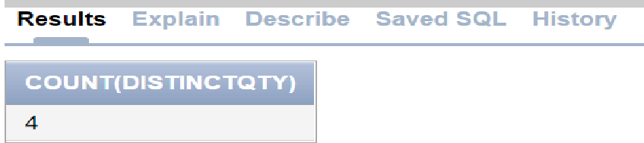

## COUNT NOT NULL QTY COMMAND:

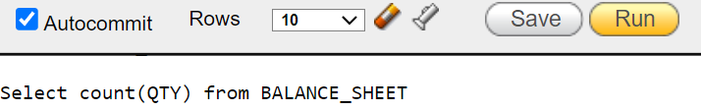

# OUTPUT:



## COUNT WITH WHERE CONDITION COMMAND:

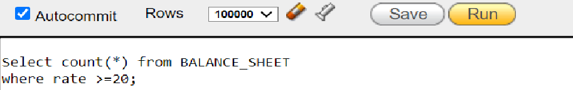

# OUTPUT:

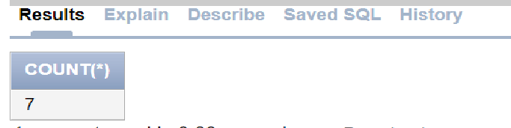

## GROUP BY COMMAND:

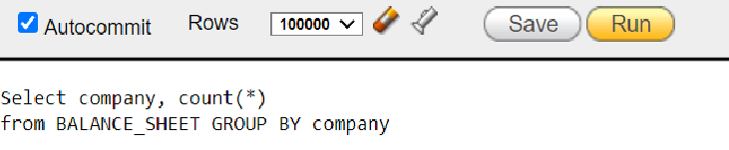

# OUTPUT:

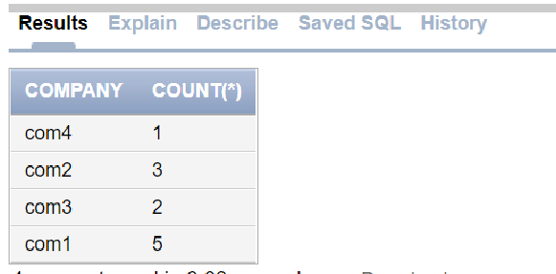

## COUNT DISTINT COMPANY COMMAND:

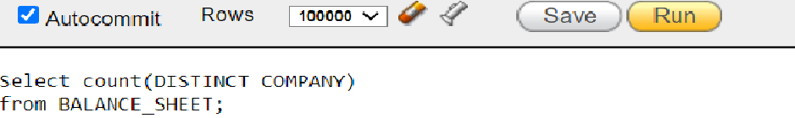

# OUTPUT:

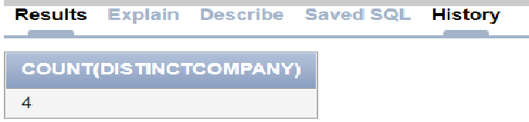

## GROUP BY HAVING COMMAND:

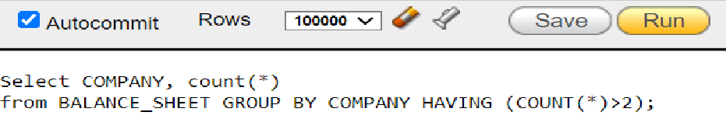

# OUTPUT:

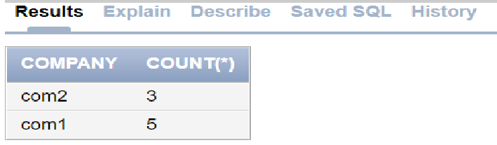

## SUM COMMAND:

## COST ADDITION COMMAND:



# OUTPUT:

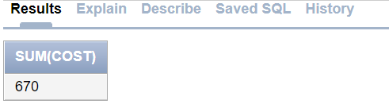

## DISTINCT COST ADDITION COMMAND:

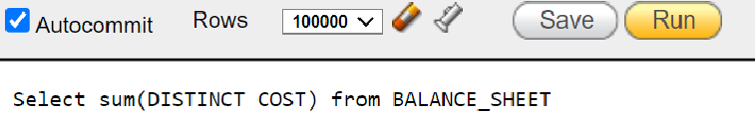

# OUTPUT:

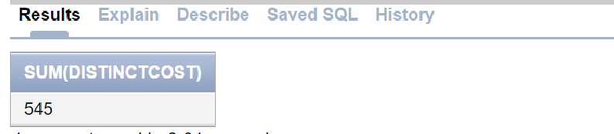

## COST ADDITION WITH WHERE CONDITION COMMAND:

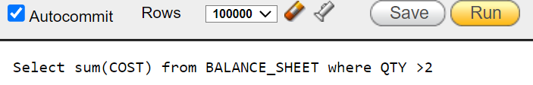

# OUTPUT:

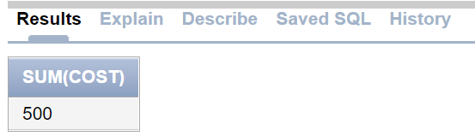

## COST ADDITION WITH GROUP BY HAVING CONDITION COMMAND:

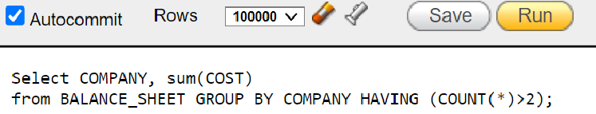

# OUTPUT:

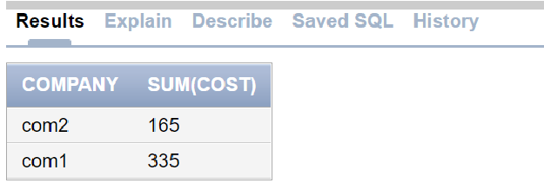

## COST ADDITION WITH WHERE AND GROUP BY COMPANY COMMAND:

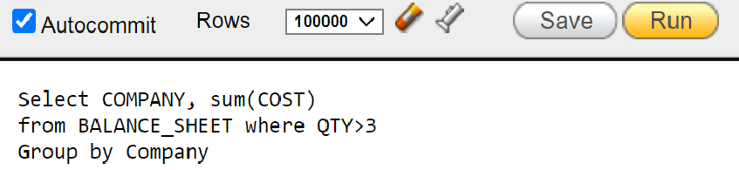

# OUTPUT:

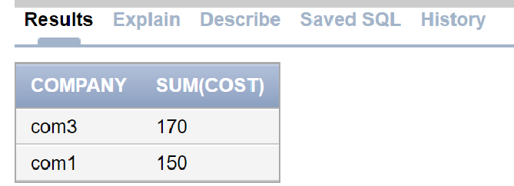

## COST ADDITION GROUP BY COMPANY COMMAND:

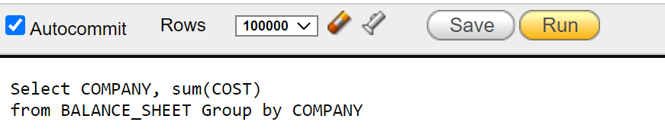

# OUTPUT:

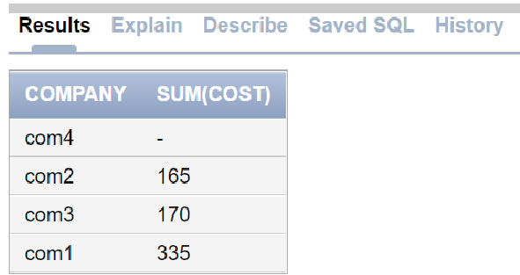

## COST ADDITION GROUP BY COMPANY HAVING COMMAND:

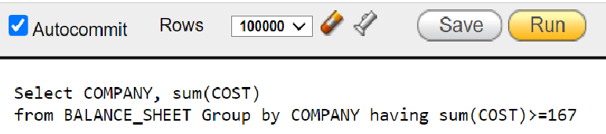

# OUTPUT:

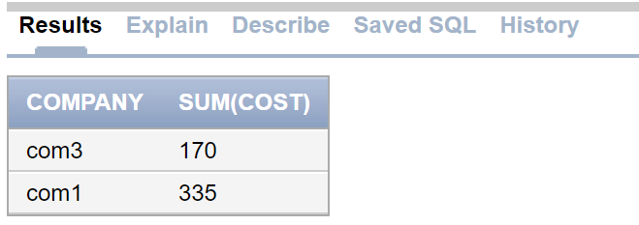

# CREATE BALANCE SHEET TABLE :

## CREATE TABLE COMMAND:

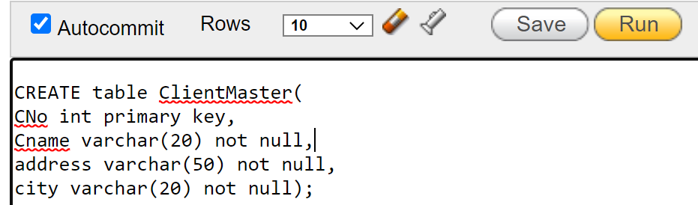

## INSERT MULTIPLE ROWS COMMANDS: